Goertzel Filters

This appendix gives the frequency responses of the Goertzel filters to be found in the file goertzel_algorithm.c. The frequency response curves were produced using the MATLAB Filter Design Toolbox.

Figure 1:

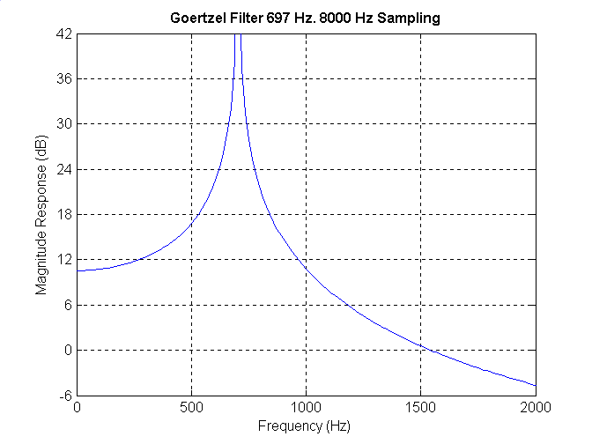

Figure 2:

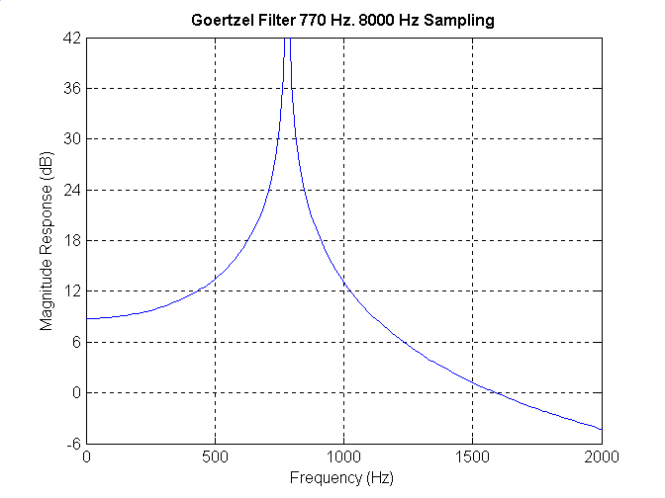

Figure 3:

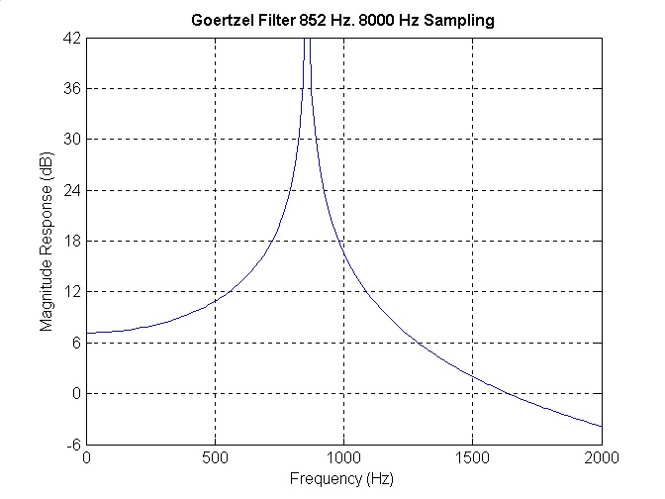

Figure 4:

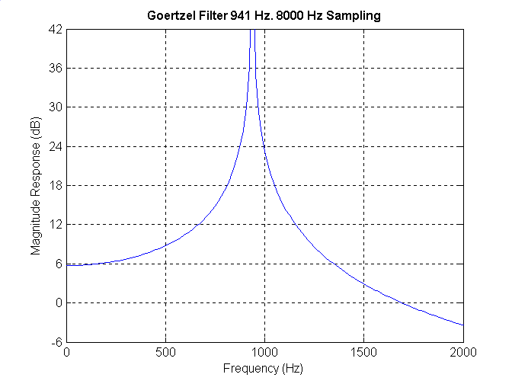

Figure 5:

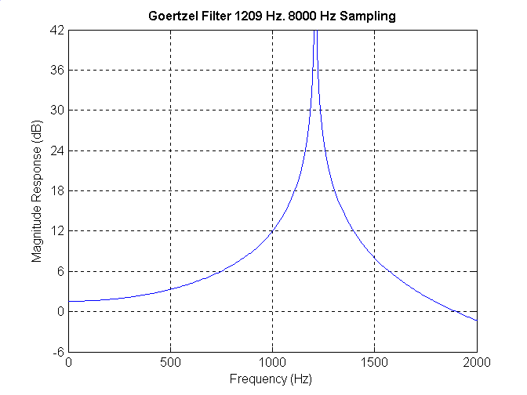

Figure 6:

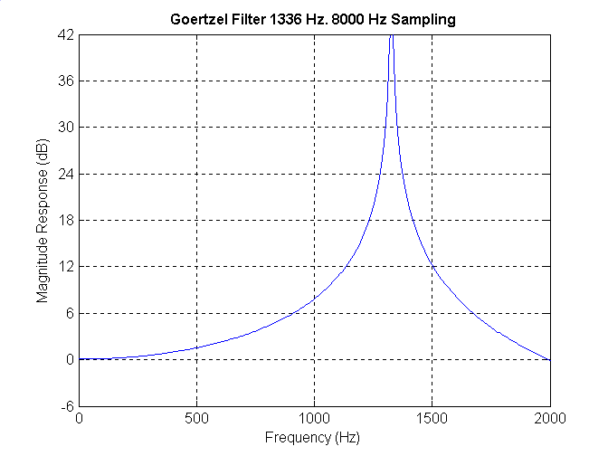

Figure 7:

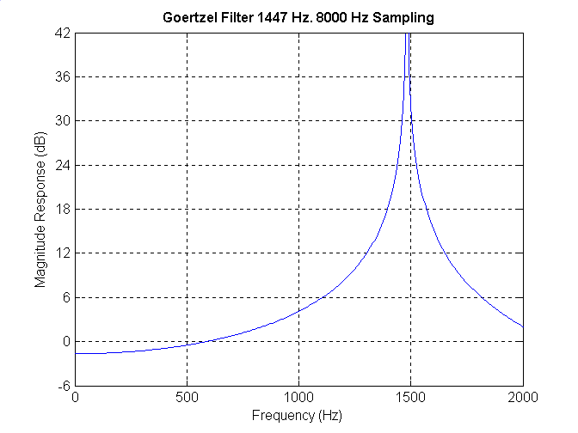

Figure 8:

