TMS320C5416 DSK: Installing the Applications

The following procedure has been written to install the application named template, which is stored in the file template.zip. For other projects, change the name template to that of the zip file being used, e.g. electronic_crossover.

This procedure takes a few minutes to execute. The program WinZip is required.

1. | Start Code Composer Studio for the TMS320C5416 DSK.
2. | Select Project -> New. For the Project Name, type in the word template. Click on the Finish button. The new project has now been created. This is shown in Figure 1. Make a note of the directory in which the project is being stored then minimise Code Composer Studio.
3. | Using Windows Explorer, go to the directory where the new project is to be stored e.g. C:\ti\myprojects\template
4. | Copy the file template.zip to the directory C:\ti\myprojects\template
5. | Extract the files from template.zip using WinZip to the current directory with the Extract Here option.
6. | Return to Code Composer Studio. Select Project -> Add Files to Project. Select the path C:\ti\myprojects\template. Use Control + left mouse click to highlight all the .c files. Click on the Open button to add the .c files to the project.
7. | Select Project -> Add Files to Project. Using the down arrow in the Files of Type box, select Configuration File (*.cdb). Use left mouse click to highlight the template.cdb file. Click on the Open button to add the template.cdb file to the project.
8. | Select Project -> Add Files to Project. Using the down arrow in the Files of Type box, select Linker Command File (*.cmd). Use left mouse click to highlight the template.cmd file. Click on the Open button to add the template.cmd file to the project.
9. | Select Project -> Add Files to Project. Using the down arrow in the Files of Type box select Asm Source Files (*.a*, *.s). Use Control + Left mouse click to highlight the .asm files (if present). Should there be .asm files in the project, click on the Open button to add the .asm file(s) to the project. Otherwise click on Cancel.
10. | Only required when using dsplib.  Select Project -> Add Files to Project. Using the down arrow in the Files of Type box select Object and Library Files (*.o*, *.lib). Use Control + Left mouse click to highlight the .lib files (if present). Click on the Open button to add the .lib file(s) to the project.
11. | There is no need to add the .h files to the project. This is done automatically.
12. | Select Project -> Build Options. The Compiler tab should be selected. Highlight the word Advanced in the Category Window. Tick the box Use Far Calls (-mf) (548 and higher). This is shown in Figure 2.
13. | Click the Linker tab at the top of the window. At the line Include Libraries (-l): type in the word dsk5416f.lib then click on OK. This is shown in Figure 3.
14. | Select Project ->Rebuild All. There should be an error and a warning. The new files templatecfg.s54 and templatecfg_c.c and templatecfg.h should have been created.
15. | Select Project -> Add Files to Project. Using the down arrow in the Files of Type box, select Linker Command File (*.cmd). Left click on templatecfg.cmd  Then click on Open. There will be a warning that there is already a .cmd file in the project. Replace the file template.cmd with the new one templatecfg.cmd by clicking on Yes.
16. | Select Option -> Customize -> Program Load Options. Tick the box Load Program after Build. This is shown in Figure 4.
17. | Select Project -> Build. This time the project should build successfully and the  File template.out should be loaded automatically.
18. | Select Debug -> Go Main to show the source code. This is shown in Figure 5. Select Debug -> Run to run the project.

Generating a New Project from the Template

If the files in template.zip are to be used as the basis of the new project my_project1, the following additional steps must be carried out after carrying out step 5. and before carrying out step 6. above:

5a. | Using Windows Explorer, rename template.c to my_project1.c
5b. | Rename template.cdb to my_project1.cdb
5c. | Rename template.cmd to my_project1.cmd
5d. | Continue from step 6, but use my_project1 instead of template.

Step 13 will fail because the compiler generated file templatecfg.h cannot be found. This is because my_project1cfg.h has been generated instead. Carry out the following steps:

15a. | Using Code Composer Studio, use File -> Open to open the file my_project1.c  Change the line #include “templatecfg.h” to #include “my_project1cfg.h”
15b. | Using Code Composer Studio, use File -> Open to open the file bargraph.c  Change the line #include “templatecfg.h” to #include “my_project1cfg.h”
15c. | Using Code Composer Studio, use File -> Open to open the file switches.c  Change the line #include “templatecfg.h” to #include “my_project1cfg.h”
15c. | Select Project -> Build. This time the project should build successfully.

Note: When renaming a project, use underscores rather than spaces between words.

Figure 1. Creating a New Project

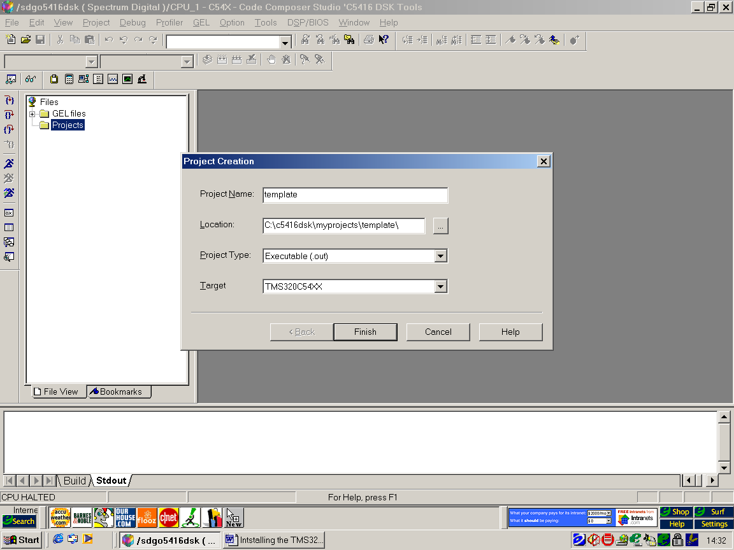

Figure 2. Setting the Compiler Options in Step 11.

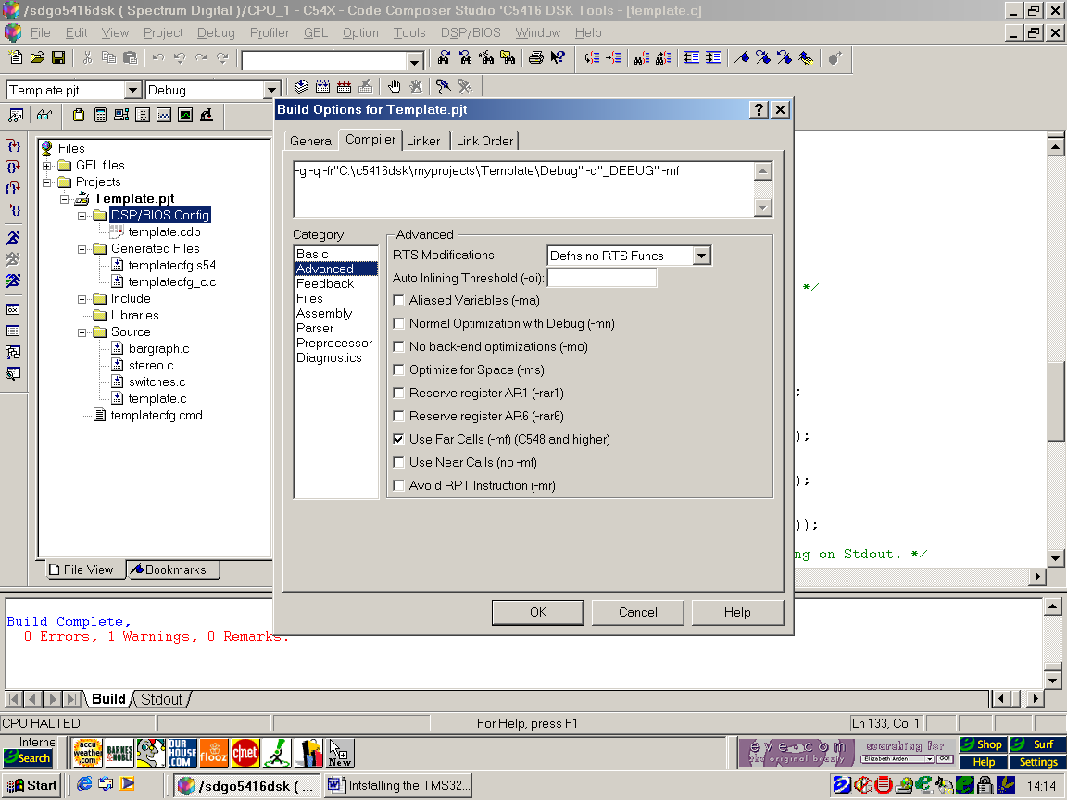

Figure 3. Setting the Linker Option in Step 11

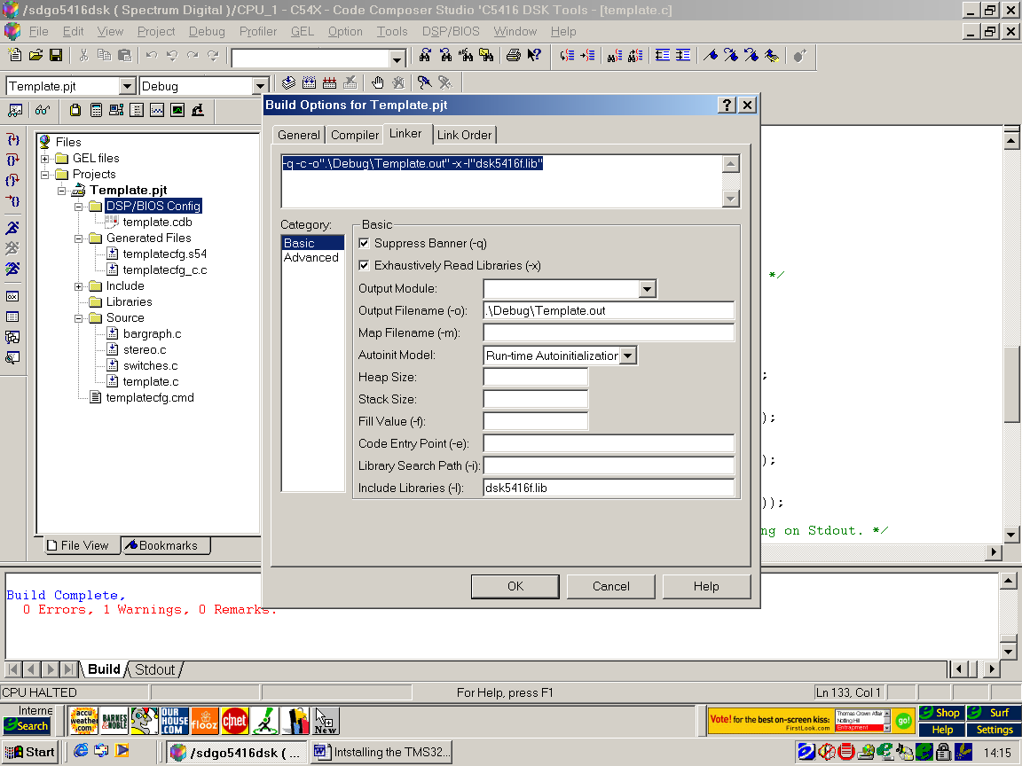

Figure 4. Setting Automatic Load of Program

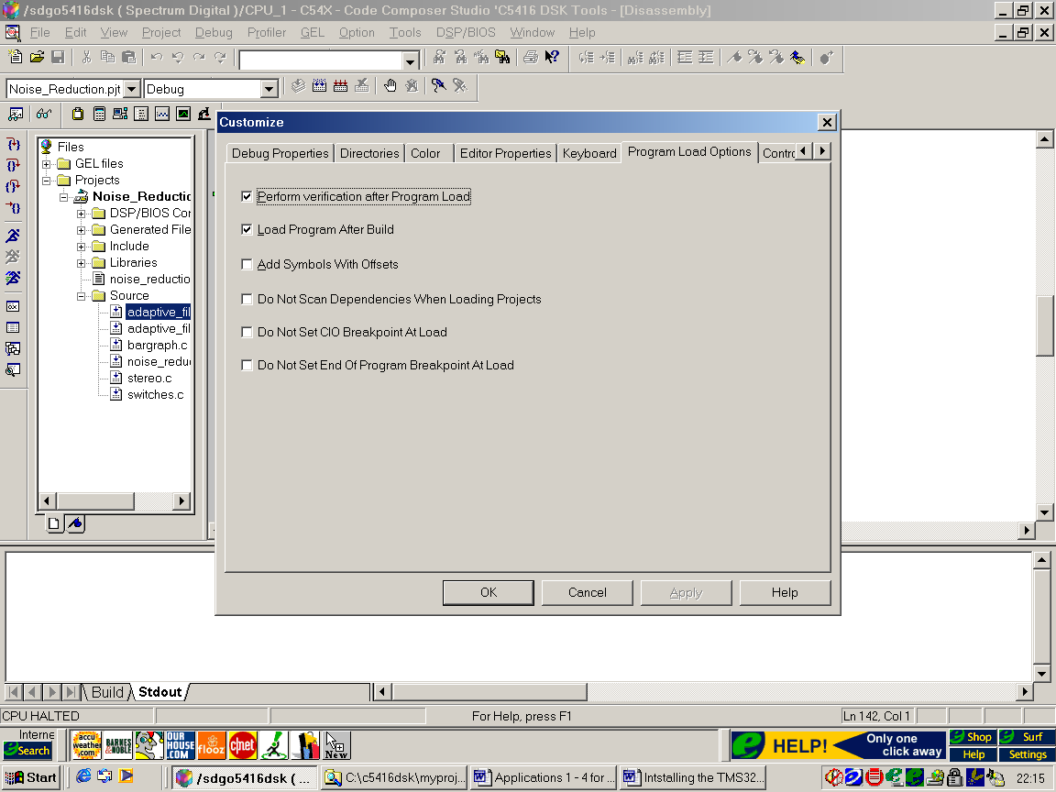

Figure 5. Project Template Installed

