FIR Windows

This appendix gives the frequency responses of the Finite Impulse Response (FIR) filters to be found in the file FIR_windows.c. The frequency response curves were produced using the MATLAB Filter Design Toolbox.

Figure 1:

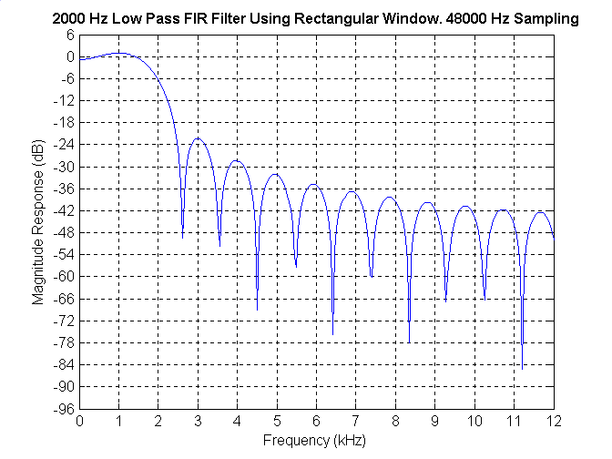

Figure 2:

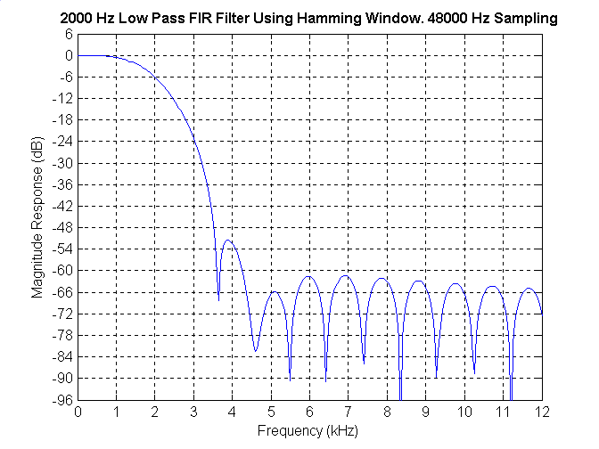

Figure 3:

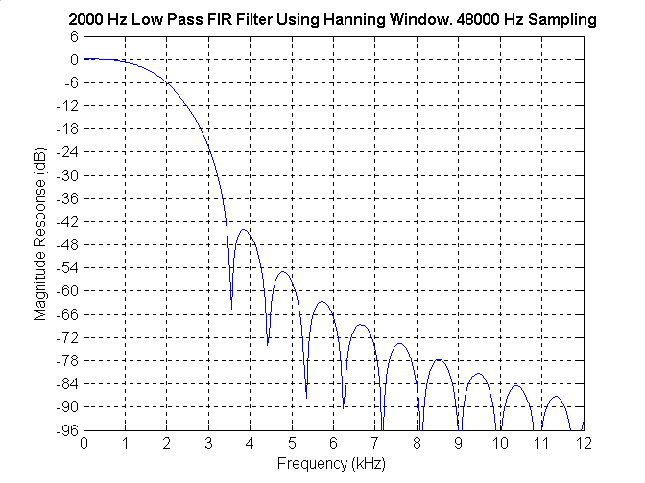

Figure 4:

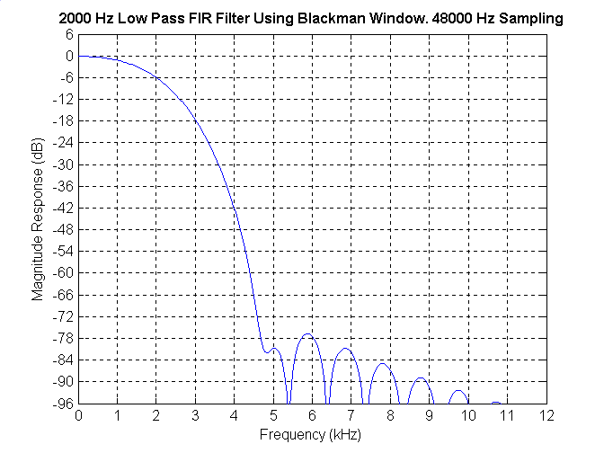

Figure 5:

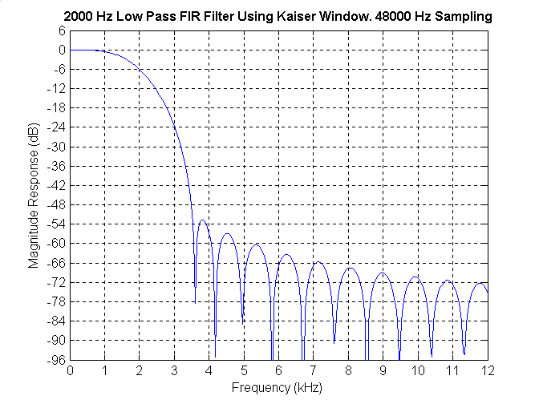

Figure 6:

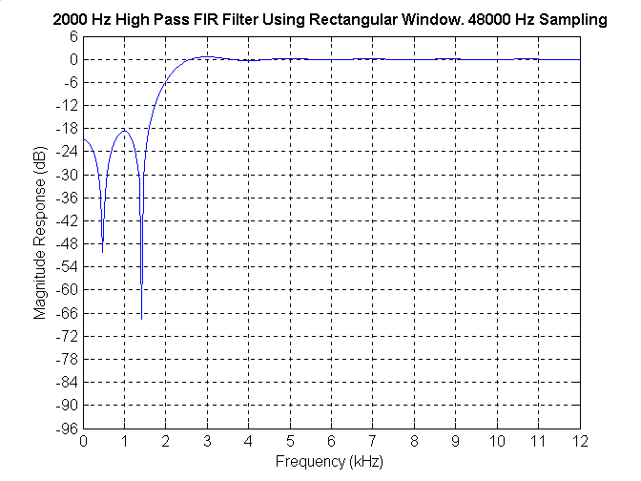

Figure 7:

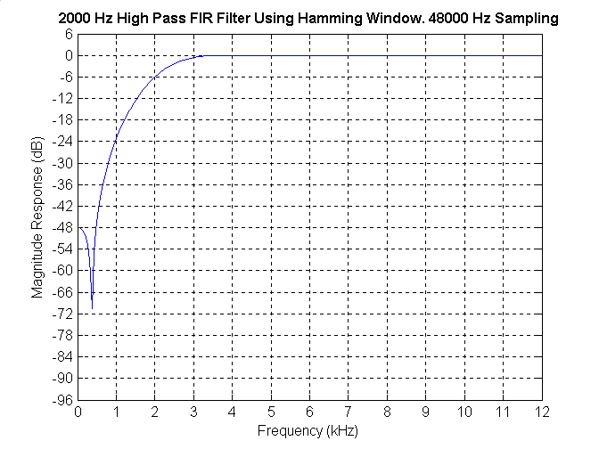

Figure 8:

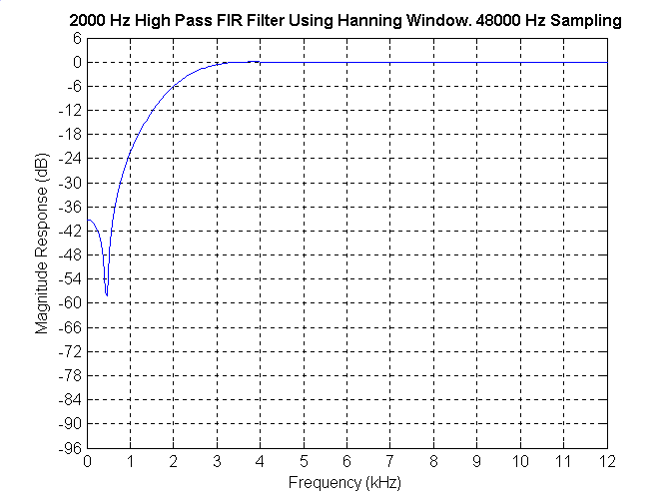

Figure 9:

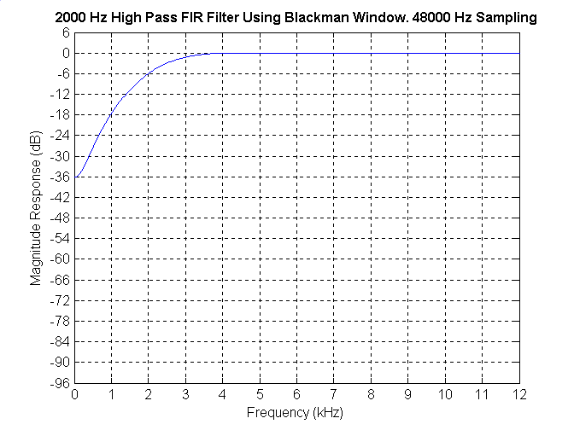

Figure 10:

